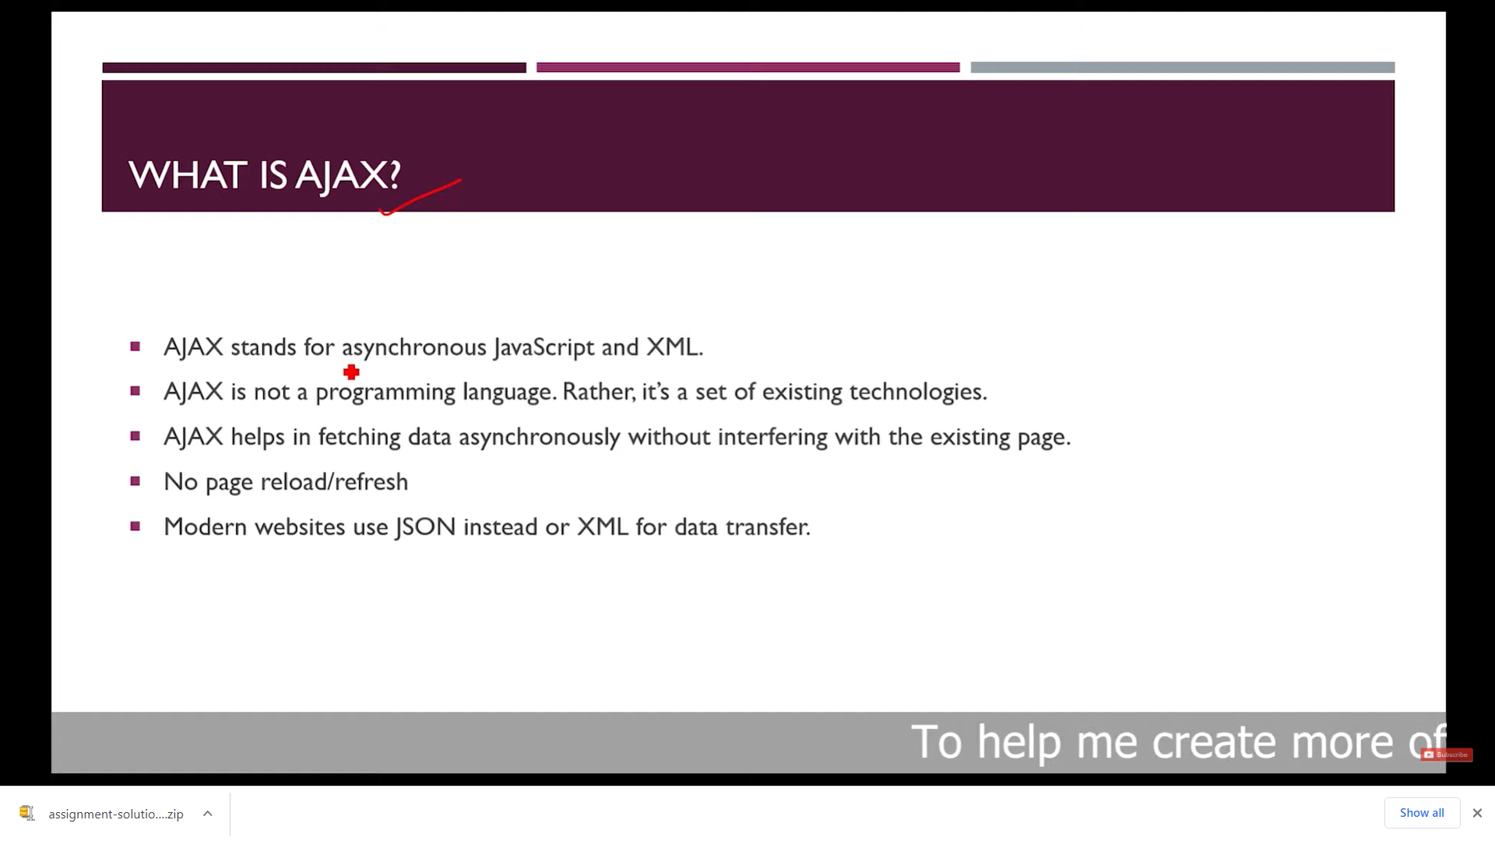

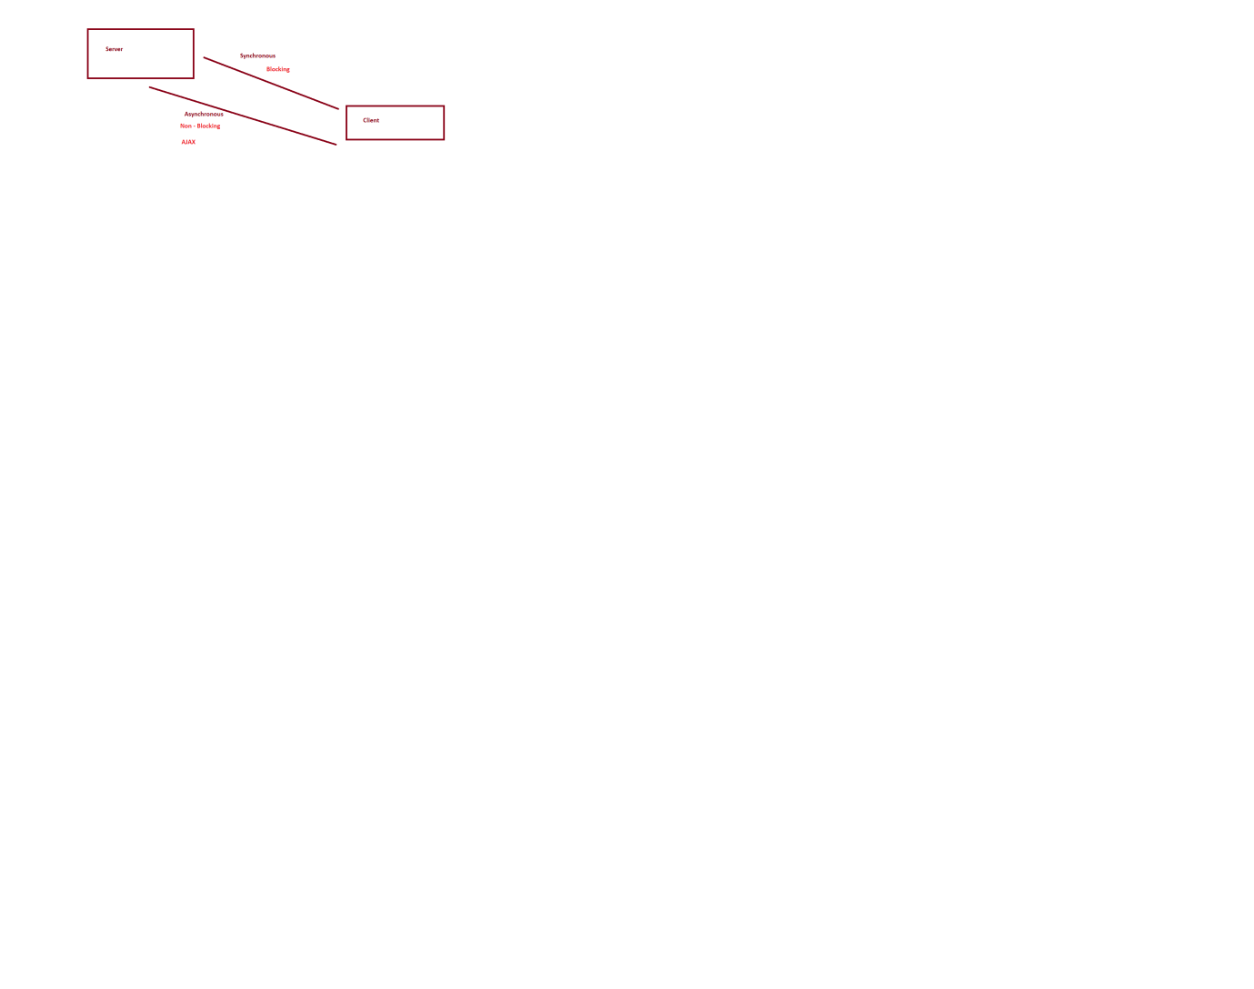

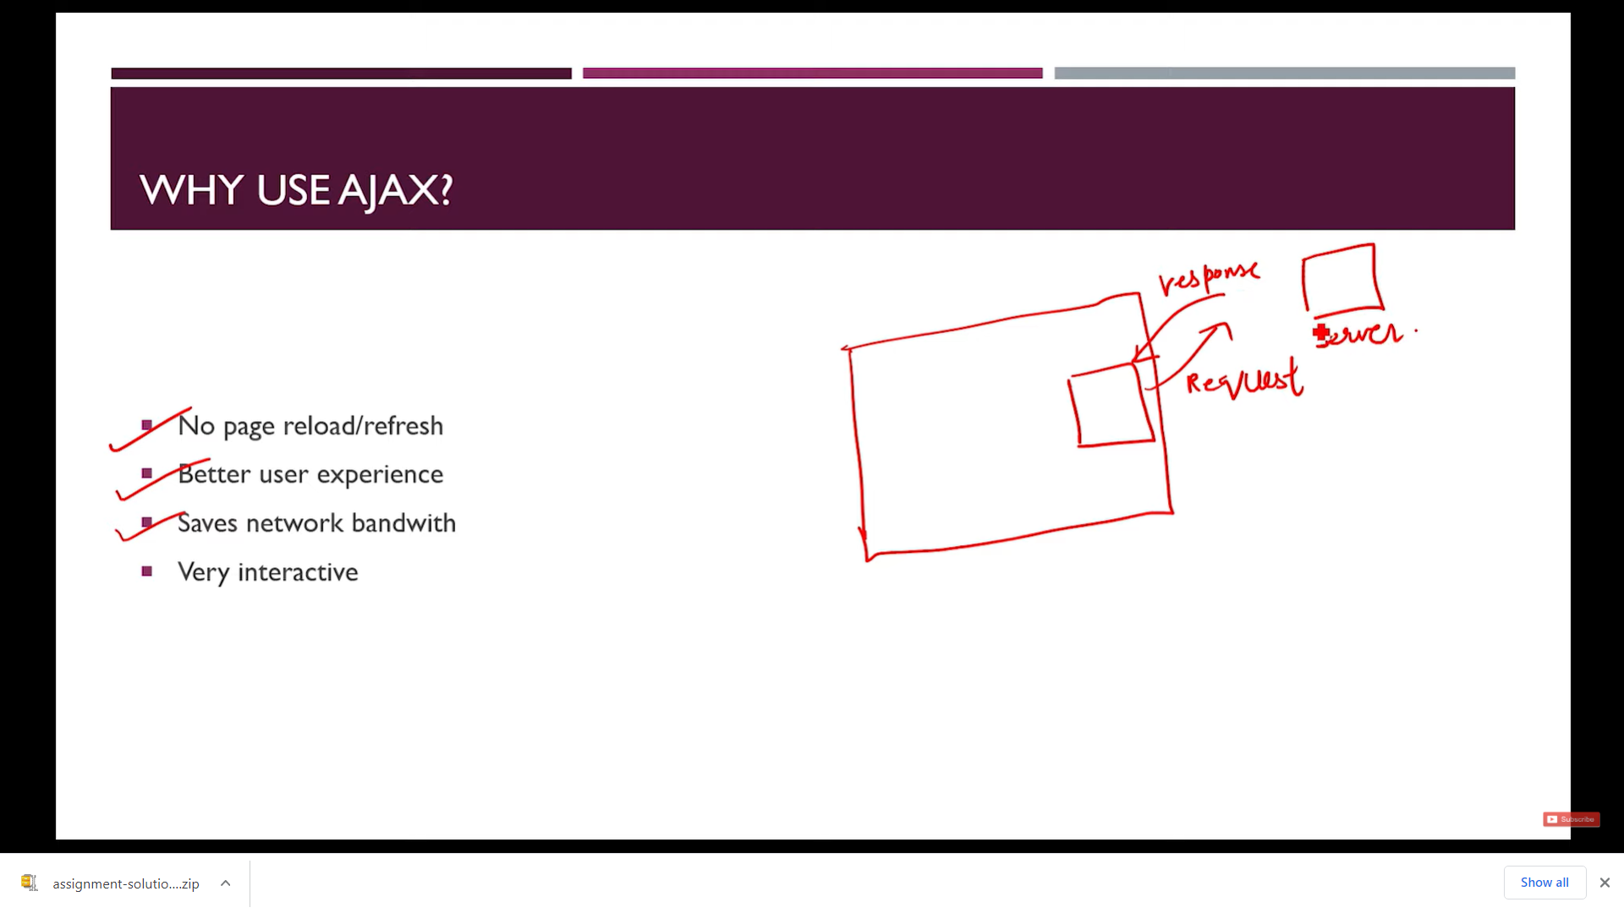

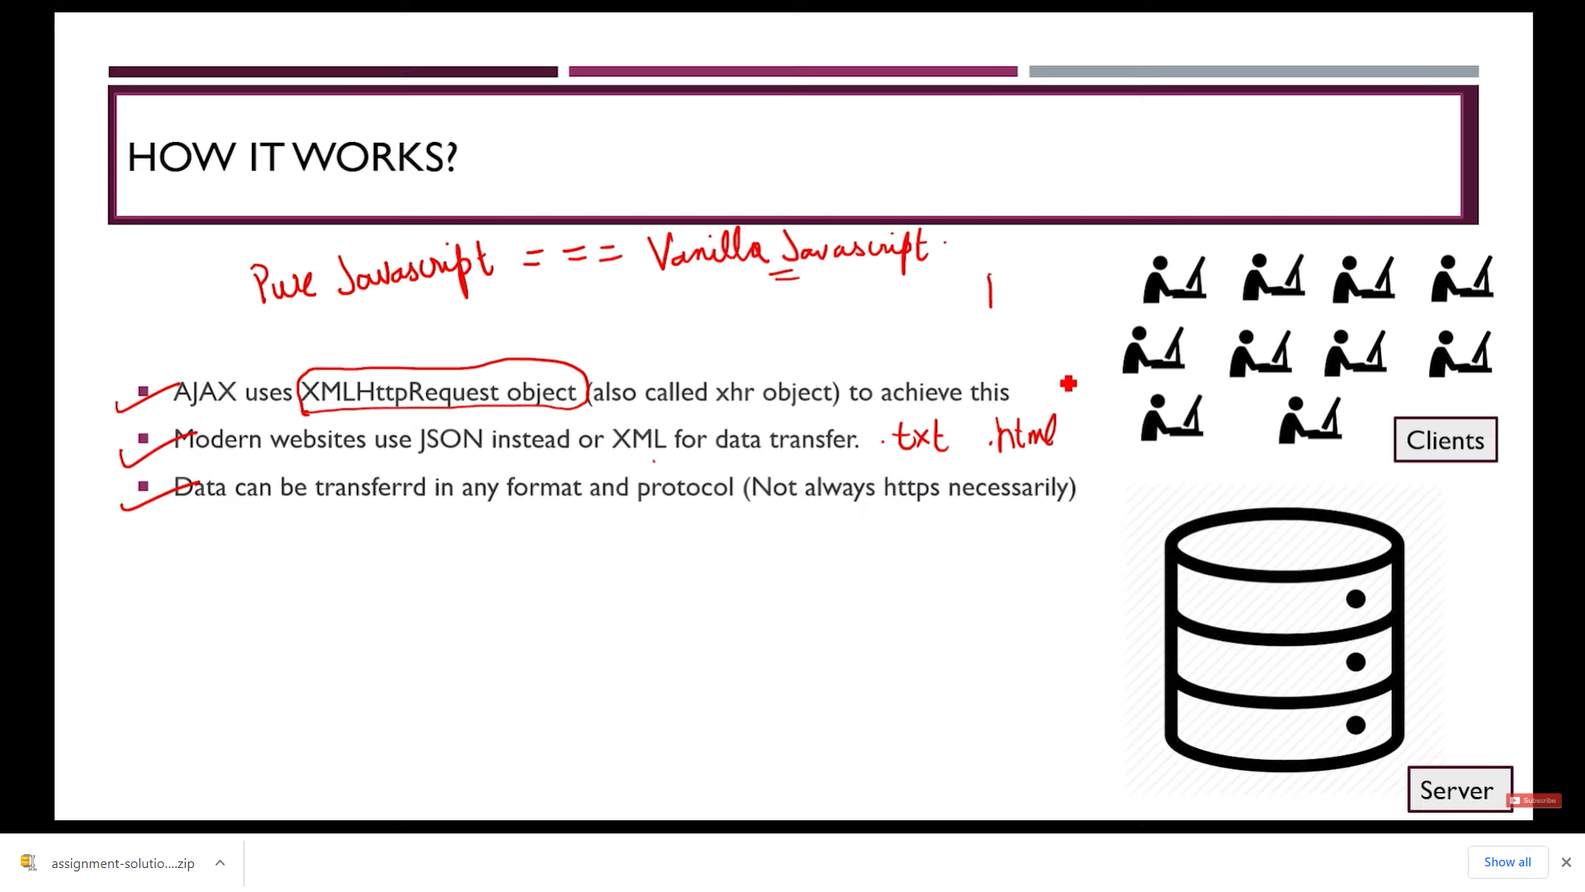

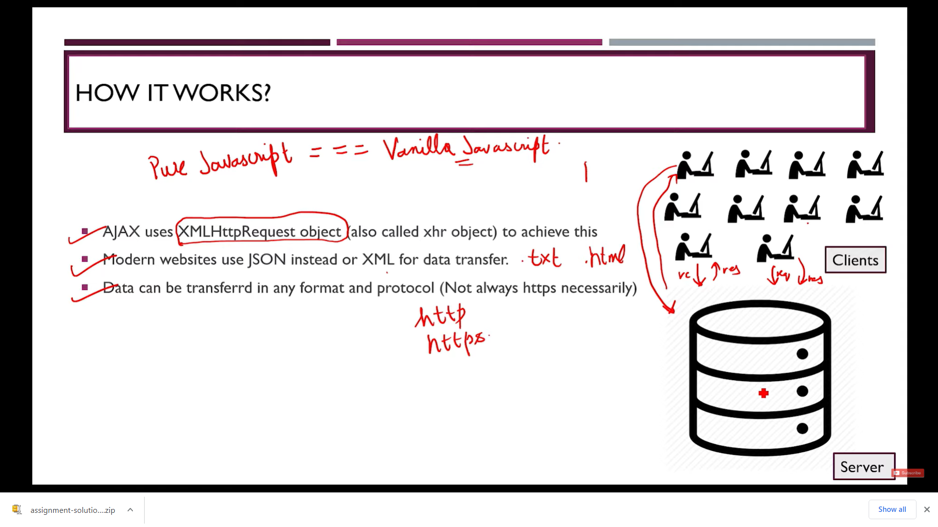

The onreadystatechange Property

The **readyState** property holds the status of the XMLHttpRequest.

The **onreadystatechange** property defines a function to be executed when the readyState changes.

The **status** property and the **statusText** property holds the status of the XMLHttpRequest object.

|  |  |
| --- | --- |
| **Property** | **Description** |
| onreadystatechange | Defines a function to be called when the readyState property  Changes |
| readyState | Holds the status of the XMLHttpRequest. 0: request not initialized 1: server connection established 2: request received 3: processing request 4: request finished and response is ready |
| status | 200: "OK" 403: "Forbidden" 404: "Page not found" For a complete list go to the [Http Messages Reference](https://www.w3schools.com/tags/ref_httpmessages.asp) |
| statusText | Returns the status-text (e.g. "OK" or "Not Found") |

The onreadystatechange function is called every time the readyState changes.

When readyState is 4 and status is 200, the response is ready:

The onreadystatechange event is triggered four times (1-4), one time for each change in the readyState.

## Using a Callback Function

A callback function is a function passed as a parameter to another function.

If you have more than one AJAX task in a website, you should create one function for executing the XMLHttpRequest object, and one callback function for each AJAX task.

The function call should contain the URL and what function to call when the response is ready.

**console.log("The javascript file is called ");**

**// Instantiate xhr object**

**var xhr = new XMLHttpRequest();**

**console.log(xhr.readyState);**

**// open the object**

**xhr.open("GET", "ajax_info.txt", true);**

**console.log(xhr.readyState);**

**xhr.onreadystatechange = handleRequestStateChange;**

**// Send the Request**

**xhr.send(null);**

**function handleRequestStateChange()**

**{**

**console.log(xhr.readyState);**

**if (xhr.readyState == 4 && xhr.status == 200) {**

**alert("if loaded");**

**document.getElementById("div1").innerHTML = xhr.responseText;**

**}**

**else {**

**console.error("some error");**

**}**

**}**

**console.log("Ajax Called");**

**let fetchbtn = document.getElementById("fetchBtn");**

**console.log(fetchbtn);**

**fetchbtn.addEventListener('click', buttonClickHandler);**

**console.log("evnet added");**

**function buttonClickHandler() {**

**console.log("Button is clicked");**

**// Instantiate xhr object**

**var xhr = new XMLHttpRequest();**

**// console.log(xhr.readyState);**

**// open the object**

**xhr.open("GET", "records.json", true);**

**// console.log(xhr.readyState);**

**xhr.onreadystatechange = handleRequestStateChange;**

**// Send the Request**

**xhr.send(null);**

**function handleRequestStateChange() { //this will work instead of var funcName=function(){}**

**console.log(xhr.readyState);**

**if (xhr.readyState == 4 && xhr.status == 200) {**

**alert("if loaded");**

**document.getElementById("d1").innerHTML = xhr.responseText;**

**}**

**//else {**

**// console.error("some error");**

**//}**

**}**

**}**

<https://jsonplaceholder.typicode.com/comments>

<https://reqres.in/api/users>

POST DATA

function buttonClickHandler() {

console.log("Button is clicked");

// Instantiate xhr object

var xhr = new XMLHttpRequest();

// console.log(xhr.readyState);

// open the object

xhr.open("POST", "https://reqres.in/api/users", true);

xhr.getResponseHeader('Content-Type', 'application/json');

params = {

"name": "Ajay",

"job": "leader"

};

// console.log(xhr.readyState);

xhr.onreadystatechange = handleRequestStateChange;

// Send the Request

xhr.send(params);

function handleRequestStateChange() { //this will work instead of var funcName=function(){}

console.log(xhr.readyState);

console.log(xhr.status);

if (xhr.readyState == 4 && xhr.status == 201) {

alert("if loaded");

document.getElementById("d1").innerHTML = xhr.responseText;

}

//else {

// console.error("some error");

//}

}

}

Populate List Box

Html

<input type="button" id="PopulateBtn" value="Populate List Box" />

<script src="ajax.js"></script>

<div>

<ul id="list">

</ul>

</div>

function populateButtonClickHandler() {

// Instantiate xhr object

var xhr = new XMLHttpRequest();

// console.log(xhr.readyState);

// open the object

xhr.open("GET", "https://jsonplaceholder.typicode.com/comments", true);

// console.log(xhr.readyState);

xhr.onreadystatechange = handleRequestStateChange;

// Send the Request

xhr.send(null);

function handleRequestStateChange() { //this will work instead of var funcName=function(){}

console.log(xhr.readyState);

if (xhr.readyState == 4 && xhr.status == 200) {

alert("if loaded");

let obj = JSON.parse(xhr.responseText);

console.log(obj);

let list = document.getElementById("list");

str = "";

for (key in obj) {

str += `<li> ${obj[key].name}</li>`;

}

list.innerHTML = str;

// document.getElementById("d1").innerHTML = xhr.responseText;

}

//else {

// console.error("some error");

//}

}

}

FINAL PROGRAM

<!DOCTYPE html>

<html>

<head>

<meta charset="utf-8" />

<title></title>

</head>

<body>

<div id="d1"></div>

<input type="button" id="fetchBtn" value="Fetch Data through Ajax" />

<input type="button" id="SendBtn" value="Send Data through Ajax" />

<input type="button" id="PopulateBtn" value="Populate List Box" />

<script src="ajax.js"></script>

<div>

<ul id="list">

</ul>

</div>

</body>

</html>

Ajax.js

console.log("Ajax Called");

let fetchbtn = document.getElementById("fetchBtn");

fetchbtn.addEventListener('click', buttonClickHandler);

console.log("evnet added");

let PopulateBtn = document.getElementById("PopulateBtn");

PopulateBtn.addEventListener('click', populateButtonClickHandler);

function buttonClickHandler() {

console.log("Button is clicked");

// Instantiate xhr object

var xhr = new XMLHttpRequest();

// console.log(xhr.readyState);

// open the object

xhr.open("POST", "https://reqres.in/api/users", true);

xhr.getResponseHeader('Content-Type', 'application/json');

params = {

"name": "Anamika Sawhney",

"job": "Consultant"

};

// console.log(xhr.readyState);

xhr.onreadystatechange = handleRequestStateChange;

// Send the Request

xhr.send(params);

function handleRequestStateChange() { //this will work instead of var funcName=function(){}

console.log(xhr.readyState);

console.log(xhr.status);

if (xhr.readyState == 4 && xhr.status == 201) {

alert("if loaded");

document.getElementById("d1").innerHTML = xhr.responseText;

}

//else {

// console.error("some error");

//}

}

}

**//function buttonClickHandler() {**

**// console.log("Button is clicked");**

**// // Instantiate xhr object**

**// var xhr = new XMLHttpRequest();**

**// // console.log(xhr.readyState);**

**// // open the object**

**// xhr.open("GET", "https://reqres.in/api/users", true);**

**// // console.log(xhr.readyState);**

**// xhr.onreadystatechange = handleRequestStateChange;**

**// // Send the Request**

**// xhr.send(null);**

**// function handleRequestStateChange() { //this will work instead of var funcName=function(){}**

**// console.log(xhr.readyState);**

**// if (xhr.readyState == 4 && xhr.status == 200) {**

**// alert("if loaded");**

**// document.getElementById("d1").innerHTML = xhr.responseText;**

**// }**

**// //else {**

**// // console.error("some error");**

**// //}**

**// }**

**// }**

function populateButtonClickHandler() {

// Instantiate xhr object

var xhr = new XMLHttpRequest();

// console.log(xhr.readyState);

// open the object

xhr.open("GET", "https://jsonplaceholder.typicode.com/comments", true);

// console.log(xhr.readyState);

xhr.onreadystatechange = handleRequestStateChange;

// Send the Request

xhr.send(null);

function handleRequestStateChange() { //this will work instead of var funcName=function(){}

console.log(xhr.readyState);

if (xhr.readyState == 4 && xhr.status == 200) {

alert("if loaded");

let obj = JSON.parse(xhr.responseText);

console.log(obj);

let list = document.getElementById("list");

str = "";

for (key in obj) {

str += `<li> ${obj[key].name}</li>`;

}

list.innerHTML = str;

// document.getElementById("d1").innerHTML = xhr.responseText;

}

//else {

// console.error("some error");

//}

}

}